Bug Finding in a facebook.com website
Software Testing Methodologies

I am finding a bug in www.facebook.com. I’ve written a test case in python using selenium web driver executing in Chrome web-browser.
My test case will automate to open a web browser (Chrome) and directly redirect to https://www.facebook.com . Then it automatically types in the default id and password given in the test-case. It will check whether we can login or not using with that email id and password provided in the test-case. The email id and password doesn’t match and hence the login is not successful in the www.facebook.com web-site.

Program:
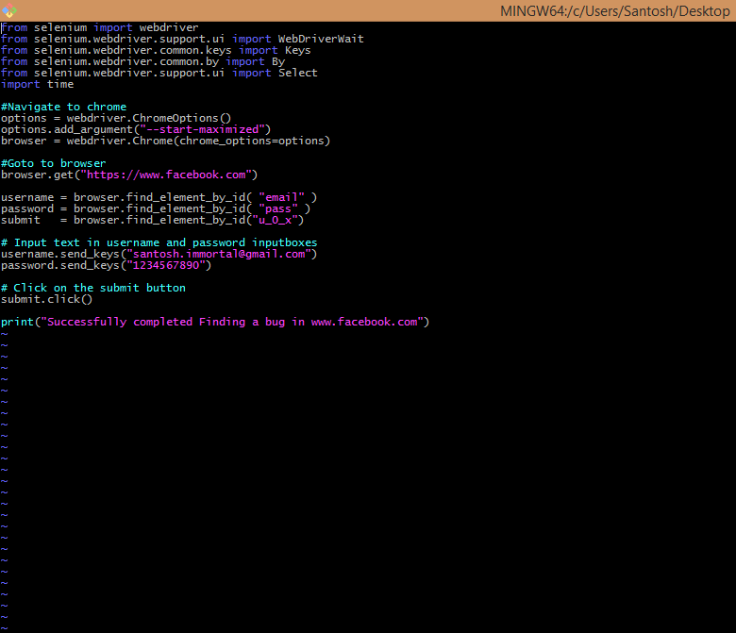

Output:
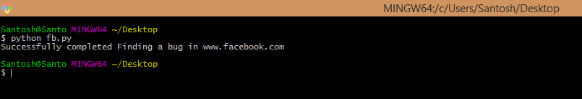

In Web browser:
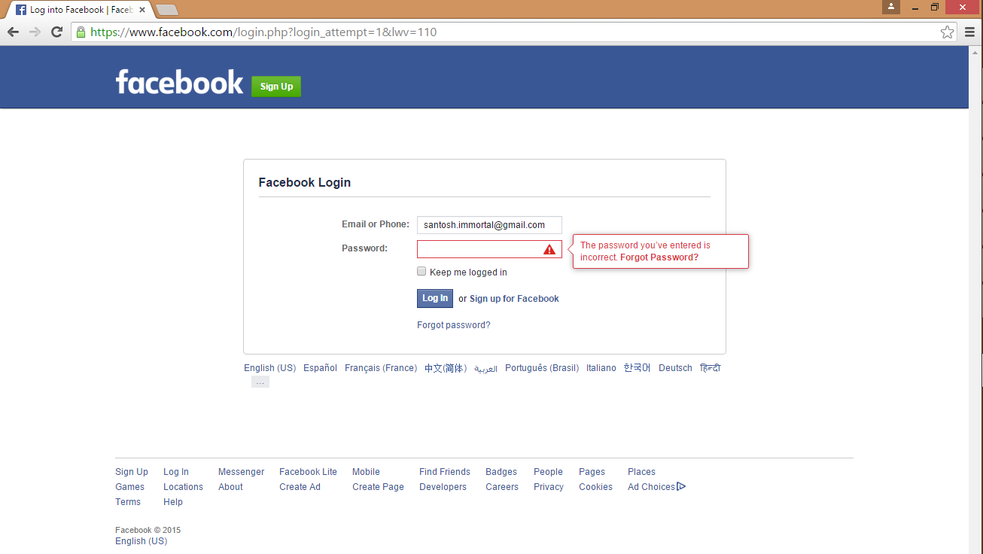

As observed, the above screenshot shows that the login doesn’t work with the email id and password provided in the test-case.

